1. Created 4 Instances in 4 region
2. Create 4 VPC in 4 region
3. Add Public subnet, Route table and IGW to each VPC
4. Create Transit gateway for every region
5. Add all the VPC’s to Transit Attachment

Eg: 1-2, 1-3, 1-4

2-3,2-4

3-4

1. Go to Transit route table and create static route add all the VPC – IP add’s

Eg: same as Transit Attachment

Eg: 1-2, 1-3, 1-4

2-3,2-4

3-4

1. Now go to Route table again and all the IP’s using Trasit gateway.
2. Now Test the PING.

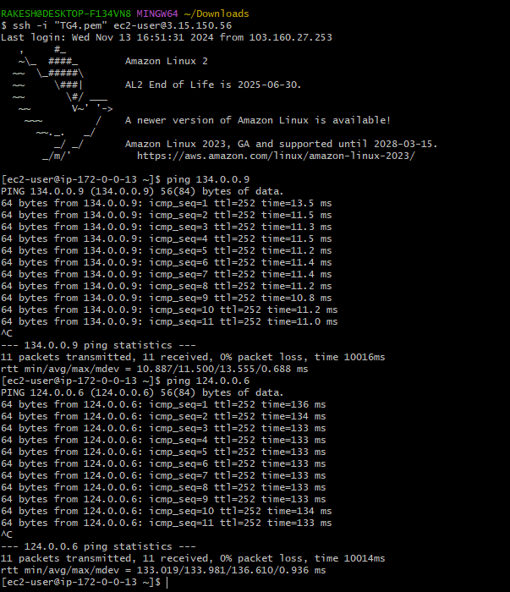

Configure VPC endpoints to securely access AWS services without internet gateways or NAT gateways, ensuring data privacy and minimizing exposure to external threats.

Checked from Public ec2

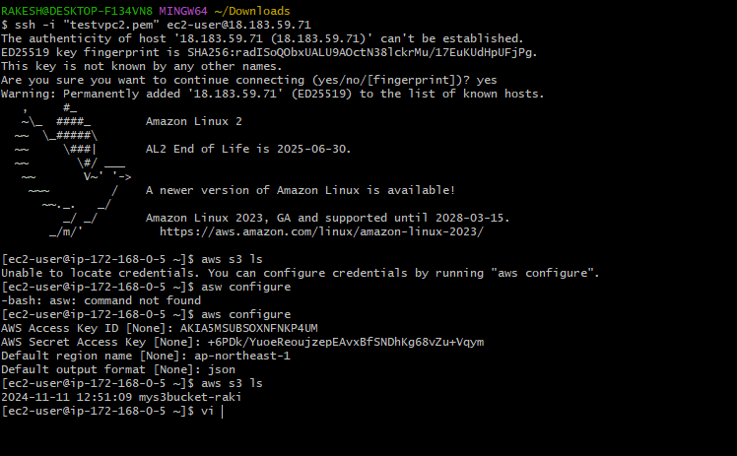

Checking from Private ec2

